Order Of Lenten Service

Opening Hymn: TLH 153

Reading: Lent IV

The History of the Passion of our Lord

Sermon Hymn: TLH 293

Sermon Text: Mark 5:1-13

Among The Tombs

Prayer

Holy Communion

The Lord's Prayer

The Blessing

Closing Hymn: TLH 155

* * * * * * * * * * * * *

Bible Study: Lambs: Water
Sheep: Proverbs 17:1-5

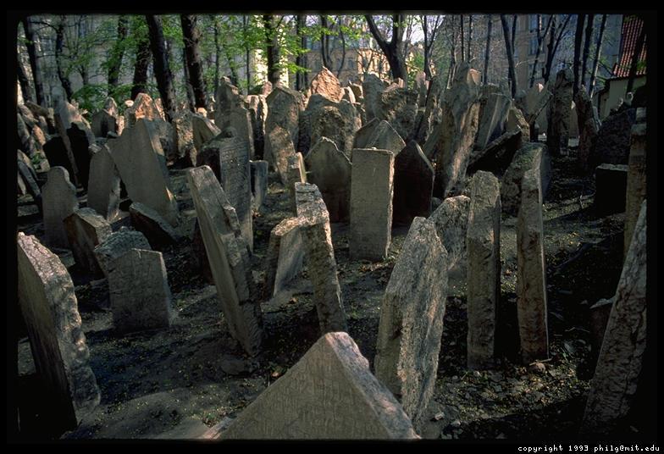

Among The Tombs

Water
Of
Life

24 March 2019

W A T E R O F L I F E

Independent Christian Church—Conservative Lutheran Doctrine

Worship Service: 9:30 a.m. Bible Study: 10:45 a.m.

Larry Cooper, Pastor E-Mail address:
111 N. Ridge Road lcooper@wateroflife.cc
Coon Valley, WI 54623 Web Site:
www.wateroflife.cc

* * * * * * * * * * * * * * * * * * * * * * * * * * *

Sermon Text: Mark 5:1-13

Among The Tombs

* * * * * * * * * * * * * * * * * * * * * * * * * * *

Mark 5:1 And they came over unto the other side of the sea, into the country of the Gadarenes.
:2 And when he was come out of the ship, immediately there met him out of the tombs a man with an unclean spirit,
:3 Who had his dwelling among the tombs; and no man could bind him, no, not with chains:
:4 Because that he had been often bound with fetters and chains, and the chains had been plucked asunder by him, and the fetters broken in pieces: neither could any man tame him.
:5 And always, night and day, he was in the mountains, and in the tombs, crying, and cutting himself with stones.

:6 But when he saw Jesus afar off, he ran and worshipped him,
:7 And cried with a loud voice, and said, What have I to do with thee, Jesus, thou Son of the most high God? I adjure thee by God, that thou torment me not.
:8 For he said unto him, Come out of the man, thou unclean spirit.
:9 And he asked him, What is thy name? And he answered, saying, My name is Legion: for we are many.
:10 And he besought him much that he would not send them away out of the country.
:11 Now there was there nigh unto the mountains a great herd of swine feeding.
:12 And all the devils besought him, saying, Send us into the swine, that we may enter into them.
:13 And forthwith Jesus gave them leave. And the unclean spirits went out, and entered into the swine: and the herd ran violently down a steep place into the sea, (they were about two thousand;) and were choked in the sea.

